Presentation Cases for Program Review

# | Case | Target | ID | Mass | SSN | Loc. | Ort. | Slice | Picture | Notes
1 | Bulk with bad streaks caused by metal | Breast milk bag 10% Saline | 6012 | 285 | 13 | bbb | z | 105 | 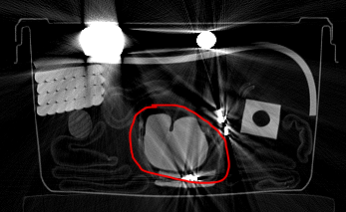
2 | Bulk with bad shading caused by beam hardening and scatter | clay | 6051 | 286 | 13 | abb | z | 128 | 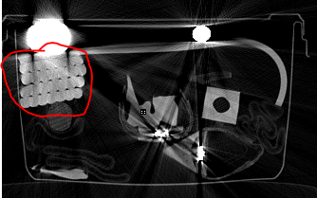
3 | Bulk inside electronics | clay | 6150 | 290 | 35 | aab | z | 49 | 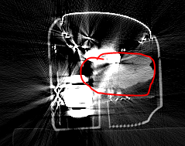
4 | Bulk with texture | clay w/ glass beads | 6193 | 309 | 193 | bbc | x | 198 | 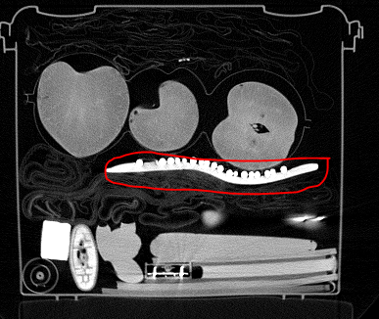
5 | Bulk with density close to water (~5% saline) | 5% saline – tin bottle | 6163 | 274 | 63 | baa | x | 45 | 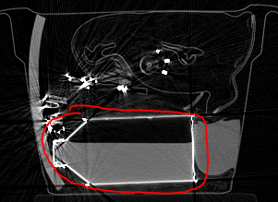
6 | Sheet with bad streaks caused by metal, beam hardening and scatter | Rubber sheet 6.6 mm | 6018 | 685 | 13 | bcb | z | 111 | 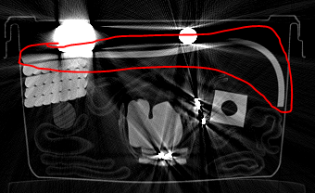
7 | Sheet laying on top of another flat object | 3/8 rubber sheet on Elle magazine | 6144 | 345 | 33 | bca | x | 46 | 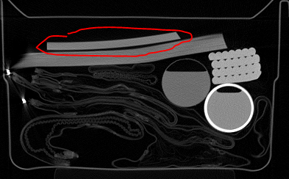
8 | Object with lots of photon starvation | rubber sheet 10 mm | 6019 | 1050 | 11 | bbb | z | 94 | 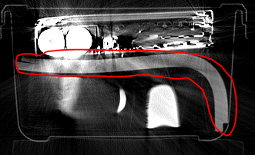
9 | PT sheet based on thickness | Neoprene rubber sheet 3.2 mm | 8026 | 350 | 18 | bab | z | 125 | 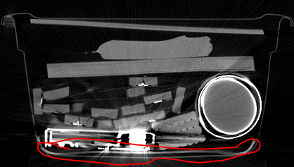
10 | PT Powder (based on density, not mass) | TA_MH01 plastic bottle + powder | 6026 | 277 | 12 | cca | x | 105 | 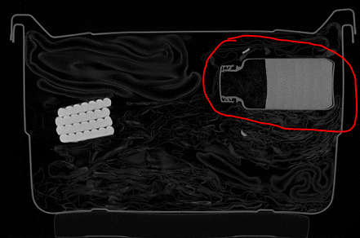 | Not required to detect this object. But interesting to know what happens with this object.

Notation
- # - case #
- Case – purpose of example
- Target – description of target
- ID – target number
- Mass – mass of target
- SSN – scan ID
- Loc – location code for target when packed
- Ort – orientation code for target when packed
- Slice – number of representative (image) shown in “Picture” column
- Picture – CT slice for slice number show in “Slice” column
- Notes – comments/notes about case

Presentation Comments
- Discuss all ten cases
- Put case number and “case” in title
- Include “Picture”.
- Say if detected or not
- If detected:
  - How the algorithm was designed to handle this case
- If not detected
  - Why wasn’t it detected?
  - Show label image for “slice”
  - Show mass, recall, precision
  - What could be done to detect the target?
  - What would be the impact on PFA?

